CME PRESENTATION REVIEW FORM

INSTRUCTIONS: Review should be conducted by a member of the planning committee. Review each presentation for the following elements, checking off as you go. If element is not present please resolve with presenter.

REVIEWER NAME: |  | CONTENT INTEGRITY ELEMENTS
PRESENTATION TITLE & APPROVED LEARNING OBJECTIVES | PRESENTER NAME | Consistent Learning Objectives | CME Appropriate Content | Balance & Scientific Integrity | No Identifiable Patient Info | Free of Commercial Promotion | Non Original Content Cited
EXAMPLE  Drug Shortages and their impact on Physicians  - Describe the common causes of drug shortages  - Locate an updated list of current and expected drug shortages  - Develop a local protocol to obtain needed drugs as they become scarce  Revise anesthetic plans when the local supply of a drug is exhausted | Barbara King, MD | X | X | X | X | X | X

Return to barbaraking@acaai.org two (2) weeks before start of activity.

TIPS FOR PRESENTATION SCREENING
- Learning Objectives: The presentation should be consistent with the approved learning objectives.

Content Balance and Scientific Integrity:

Presentations are based on evidence accepted within the profession of medicine as adequate justification for their indication and contraindications in the case of patients.

Research, including clinical trial data conforms to generally accepted standards of experimental design, data collection and analysis.

Presentations address areas of physician practice and are balanced, discussing both the risks and benefits of recommendations, treatments or manner of practice.
- What is NOT allowed:
  - Identifiable patient information
  - Brand names, Product or manufacturer names
  - Use of copyrighted materials (without permission) if presentation will be published or distributed outside of activity
- Original Source:
  - Any non‐original material –figures, charts, graphs, images – should be cited.
  - Citation should be in a manner that makes it retrievable –footnoted if there’s a reference list or at minimal; author’s last name, first initial, name of publication and year.
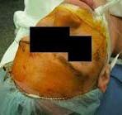 | 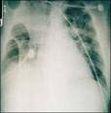  Murphy, Diane | 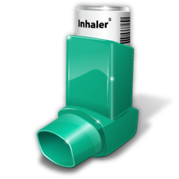
Resource  Name | Retail/ Community  (n=480) | Hospital/  Mental Health  (n=74) | Other (n=50) | Total (n=604)
PDA | 82 | 24 | 12 | 118
Use=Yes | 17.1%c | 32.4% | 24.0% | 19.5%
PDA | 398 | 50 | 38 | 486
Use=No | 82.9% | 67.6% | 76.0% | 80.5%
Data from Schrimsher, Freeman, Kendrach15

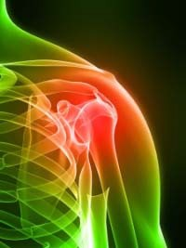
Source: Landman, P.
Body Part, 2009

