Put it in Practice
Omalizumab vs. Mepolizumab for Asthma Patients:
How to Decide
Indications
Omalizumab | Mepolizumab
Asthma  Omalizumab is indicated for patients 6 years of age and older with moderate to severe persistent asthma who have a positive skin test or in vitro reactivity to a perennial aeroallergen and whose symptoms are inadequately controlled with inhaled corticosteroids.  Omalizumab has been shown to decrease the incidence of asthma exacerbations in these patients.  Limitations Of Use  - Omalizumab is not indicated for the relief of acute bronchospasm or status asthmaticus.  - Omalizumab is not indicated for treatment of other allergic conditions.  Chronic Idiopathic Urticaria (CIU)  Omalizumab is indicated for the treatment of adults and adolescents 12 years of age and older with chronic idiopathic urticarial who remain symptomatic despite H1 antihistamine treatment.  Limitation Of Use  Omalizumab is not indicated for treatment of other forms of urticaria. | Asthma  Mepolizumab is indicated for the add-on maintenance treatment of patients with severe asthma aged 12 years and older, and with an eosinophilic phenotype. [See Clinical Studies]  Limitations of Use  - Mepolizumab is not indicated for treatment of other eosinophilic conditions.  - Mepolizumab is not indicated for the relief of acute bronchospasm or status asthmaticus.

Dosage
Omalizumab | Mepolizumab
Dosage For Asthma  Administer Omalizumab 75 to 375 mg by subcutaneous injection every 2 or 4 weeks. Determine dose (mg) and dosing frequency by serum total IgE level (IU/mL) measured before the start of treatment, and by body weight (kg).  Adjust doses for significant changes in body weight during treatment (see Table 1, 2 and 3).  Total IgE levels are elevated during treatment and remain elevated for up to one year after the discontinuation of treatment. Therefore, re-testing of IgE levels during Omalizumab treatment cannot be used as a guide for dose determination.  - Interruptions lasting less than one year: Dose based on serum IgE levels obtained at the initial dose determination.  - Interruptions lasting one year or more: Re-test total serum IgE levels for dose determination using Table 1, 2, or 3 based on the patient's age.  Periodically reassess the need for continued therapy based upon the patient's disease severity and level of asthma control.  Adult and adolescent patients 12 years of age and older: Initiate dosing according to Table 1 or 2.  Table 1: Subcutaneous Omalizumab Doses Every 4 Weeks for Patients 12 Years of Age and Older with Asthma  PRE-TREATMENT BODY WEIGHT  SERUM IGE 30-60 KG > 60-70 KG > 70-90 KG > 90-150 KG  ≥ 30-100 IU/mL 150 mg 150 mg 150 mg 300 mg  > 100-200 IU/mL 300 mg 300 mg 300 mg  > 200-300 IU/mL 300 mg  > 300-400 IU/mL SEE TABLE 2  > 400-500 IU/mL  > 500-600 IU/mL  Table 2: Subcutaneous Omalizumab Doses Every 2 Weeks for Patients 12 Years of Age and Older with Asthma  PRE-TREATMENT BODY WEIGHT  SERUM IGE 30-60 KG > 60-70 KG > 70-90 KG > 90-150 KG  ≥ 30-100 IU/mL SEE TABLE 1  > 100-200 IU/mL 225 mg  > 200-300 IU/mL 225 mg 225 mg 300 mg  > 300-400 IU/mL 225 mg 225 mg 300 mg  > 400-500 IU/mL 300 mg 300 mg 375mg  > 500-600 IU/mL 300 mg 375 mg DO NOT DOSE  > 600-700 IU/mL 375 mg  Table 3: Subcutaneous Omalizumab Doses Every 2 or 4 Weeks* for Pediatric Patients with Asthma Who Begin Omalizumab Between the Ages of 6 to < 12 Years  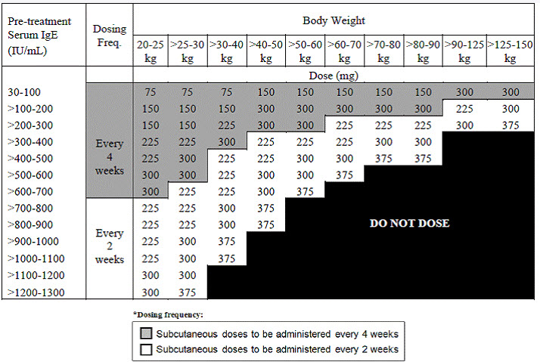  Preparation and Administration  For information regarding preparation and administration, please visit:  http://www.rxlist.com/xolair-drug/indications-dosage.htm | Recommended Dosage  Mepolizumab is for subcutaneous use only.  The recommended dose of mepolizumab is 100 mg administered once every 4 weeks by subcutaneous injection into the upper arm, thigh, or abdomen.  Preparation And Administration  Mepolizumab should be reconstituted and administered by a healthcare professional. In line with clinical practice, monitoring of patients after administration of biologic agents is recommended.  Reconstitution Instructions  - Reconstitute mepolizumab in the vial with 1.2 mL Sterile Water for Injection, USP, preferably using a 2-or 3-mL syringe and a 21-G needle. The reconstituted solution will contain a concentration of 100 mg/mL mepolizumab. Do not mix with other medications.  - Direct the stream of Sterile Water for Injection vertically onto the center of the lyophilized cake. Gently swirl the vial for 10 seconds with a circular motion at 15-second intervals until the powder is dissolved. Note: Do not shake the reconstituted solution during the procedure as this may lead to product foaming or precipitation. Reconstitution is typically complete within 5 minutes after the Sterile Water for Injection has been added, but it may take additional time.  - If a mechanical reconstitution device (swirler) is used to reconstitute mepolizumab, swirl at 450 rpm for no longer than 10 minutes. Alternatively, swirling at 1,000 rpm for no longer than 5 minutes is acceptable.  - Visually inspect the reconstituted solution for particulate matter and clarity before use. The solution should be clear to opalescent and colorless to pale yellow or pale brown, essentially particle free. Small air bubbles, however, are expected and acceptable. If particulate matter remains in the solution or if the solution appears cloudy or milky, discard the solution.  - If the reconstituted solution is not used immediately:  - store below 30°C (86°F),  - do not freeze, and  - discard if not used within 8 hours of reconstitution.  Administration  - For subcutaneous administration, preferably using a 1-mL polypropylene syringe fitted with a disposable 21-to 27-G x 0.5-inch (13-mm) needle.  - Just before administration, remove 1 mL of reconstituted mepolizumab. Do not shake the reconstituted solution during the procedure as this could lead to product foaming or precipitation.  - Administer the 1-mL injection (equivalent to 100 mg mepolizumab) subcutaneously into the upper arm, thigh, or abdomen.

Side Effects
Omalizumab | Mepolizumab
ADVERSE REACTION Omalizumab N = 738 PLACEBO N = 717  Body as a whole  Pain 7% 5%  Fatigue 3% 2%  Musculoskeletal system  Arthralgia 8% 6%  Fracture 2% 1%  Leg pain 4% 2%  Arm pain 2% 1%  Nervous system  Dizziness 3% 2%  Skin and appendages  Pruritus 2% 1%  Dermatitis 2% 1%  Special senses  Earache 2% 1% | ADVERSE REACTION (MEPOLIZUMAB 100 MG SUBCUTANEOUS (N = 263) % PLACEBO (N = 257) %  Headache 19 18  Injection site reaction 8 3  Back pain 5 4  Fatigue 5 4  Influenza 3 2  Urinary tract infection 3 2  Abdominal pain upper 3 2  Pruritus 3 2  Eczema 3 < 1  Muscle spasms 3 < 1

Time to Improvement
Omalizumab | Mepolizumab
Up to 12 weeks for improvement of chronic idiopathic/spontaneous urticarial (3 doses at 4 week interval) | Significant improvement at around four months (4 injections).
Please note: some patients may respond better to one agent versus another.
Further work is needed to determine better phenotypic discriminators of efficacy regarding specific agents.

Omalizumab vs. Mepolizumab
“If you are deciding between [mepolizumab] vs [omalizumab], if the eosinophil count is very high, [mepolizumab] may be a better option. For [omalizumab], if the IgE count is very high along with very elevated perennial allergens (i.e. dust mites, cats, dogs, mold) and those are the major triggers of your asthma, [omalizumab] may work better. Although for [omalizumab] the upper limit of the IgE level is 700 IU/ml, if your IgE level is above that, you would not qualify for [omalizumab]. For [mepolizumab] there is no upper limit of the eosinophil count to qualify for the medication.”
http://allergylosangeles.com/allergy-blog/new-asthma-drug-[mepolizumab]-mepolizumab-for-severe-eosinophilic-asthma/

“An indirect comparison versus omalizumab found trends in favor of mepolizumab in reducing the rate of clinically significant exacerbation among treatment-eligible severe asthma patients.”
Funding: GSK (HO-13-9058).
http://www.jacionline.org/article/S0091-6749(15)02139-9/pdf

“…the newest light on biologic factors in asthma appears to illuminate better the path to further research rather than provide solutions to the challenge of improving outcomes in patients with difficult-to-treat asthma.”
http://www.jmcp.org/doi/pdf/10.18553/jmcp.2009.15.3.289

