**Instructions**: Presentation review should be conducted by a member of the planning committee. Ensure that each presentation meets all the “Content Integrity Elements;” if not, please resolve with the presenter and indicate the COI Resolution Method. Return to Barb King at [barbaraking@acaai.org](mailto:barbaraking@acaai.org) a minimum of **2 weeks** before the start of the activity.

|  |  |  |  |  |  |  |  |  |
| --- | --- | --- | --- | --- | --- | --- | --- | --- |
|  |  | **Content Integrity Elements** | | | | | |  |
| **Presentation Title & Approved Learning Objectives** | **Presenter Name** | **Consistent Learning Objectives** | **CME Appropriate Content** | **Balance & Scientific Integrity** | **No Identifiable Patient Info** | **Free of Commercial Promotion** | **Non-Original Content Cited** | **Conflict of Interest (COI) Resolution** |
| **Example**  ***Drug Shortages and their impact on Physicians***   1. *Describe the common causes of drug shortages* 2. *Locate an updated list of current and expected drug shortages* 3. *Develop a local protocol to obtain needed drugs as they become scarce* 4. *Revise anesthetic plans when the local supply of a drug is exhausted* | *John Doe, MD* | *X* | *X* | *X* | *X* | *X* | *X* | No COI found  Changes made, content approved  COI not resolvable, remove presenter |
|  |  |  |  |  |  |  |  | No COI found  Changes made, content approved  COI not resolvable, remove presenter |
|  |  |  |  |  |  |  |  | No COI found  Changes made, content approved  COI not resolvable, remove presenter |
|  |  |  |  |  |  |  |  | No COI found  Changes made, content approved  COI not resolvable, remove presenter |
|  |  |  |  |  |  |  |  | No COI found  Changes made, content approved  COI not resolvable, remove presenter |
|  |  |  |  |  |  |  |  | No COI found  Changes made, content approved  COI not resolvable, remove presenter |
|  |  |  |  |  |  |  |  | No COI found  Changes made, content approved  COI not resolvable, remove presenter |
|  |  |  |  |  |  |  |  | No COI found  Changes made, content approved  COI not resolvable, remove presenter |
|  |  |  |  |  |  |  |  | No COI found  Changes made, content approved  COI not resolvable, remove presenter |
|  |  |  |  |  |  |  |  | No COI found  Changes made, content approved  COI not resolvable, remove presenter |
|  |  |  |  |  |  |  |  | No COI found  Changes made, content approved  COI not resolvable, remove presenter |
|  |  |  |  |  |  |  |  | No COI found  Changes made, content approved  COI not resolvable, remove presenter |
|  |  |  |  |  |  |  |  | No COI found  Changes made, content approved  COI not resolvable, remove presenter |
|  |  |  |  |  |  |  |  | No COI found  Changes made, content approved  COI not resolvable, remove presenter |

|  |  |  |  |  |
| --- | --- | --- | --- | --- |
|  |  |  |  |  |
| **Signature of MD/DO (e.g. Planning Committee Chair) Printed Name Date** | | | | |

**Tips for Presentation Review**

1. **Learning Objectives:** The presentation should be consistent with the approved learning objectives.
2. **Content Balance and Scientific Integrity:**
   1. Presentations are based on evidence accepted within the profession of medicine as adequate justification for their indication and contraindications in the case of patients.
   2. Research, including clinical trial data, conforms to generally accepted standards of experimental design, data collection and analysis.
   3. Presentations address areas of physician practice and are balanced, discussing both the risks and benefits of recommendations, treatments or manner of practice.
3. **What is NOT allowed:**
   1. Identifiable patient information
   2. Brand names, Product or manufacturer names
   3. Use of copyrighted materials (without permission) if presentation will be published or distributed outside of activity
4. **Original Source:**
   1. Any non‐original material (e.g. figures, charts, graphs, images), should be cited.
   2. Citation should be in a manner that makes it retrievable; footnoted if there’s a reference list or at minimal: author’s last name, first initial, name of publication and year.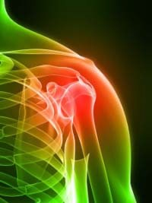



Source: Landman, P.

Body Part, 2009

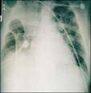

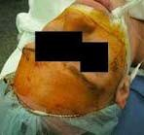

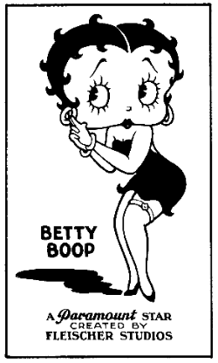



|  |  |  |  |  |
| --- | --- | --- | --- | --- |
| **Resource**  **Name** | **Retail/ Community**  **(n=480)** | **Hospital/**  **Mental Health**  **(n=74)** | **Other (n=50)** | **Total (n=604)** |
| PDA | 82 | 24 | 12 | 118 |
| Use=Yes | 17.1%c | 32.4% | 24.0% | 19.5% |
| PDA | 398 | 50 | 38 | 486 |
| Use=No | 82.9% | 67.6% | 76.0% | 80.5% |
| Data from Schrimsher, Freeman, Kendrach15 | | | | |

