

**CME Presentation Review Form  
 <Insert Joint Provider Name>│ <Insert Meeting Title>**

**<Insert Meeting Date(s)> │ <Insert Meeting Location>**

**Instructions**: Review should be conducted by a member of the planning committee. Review each presentation for the following elements, checking off as you go. If element is not present, please resolve with presenter.

|  |  |
| --- | --- |
| **Reviewer Name (MD/DO)** |  |

|  |  |  |  |  |  |  |  |
| --- | --- | --- | --- | --- | --- | --- | --- |
|  |  | **Content Integrity Elements** | | | | | |
| **Presentation Title & Approved Learning Objectives** | **Presenter Name** | **Consistent Learning Objectives** | **CME Appropriate Content** | **Balance & Scientific Integrity** | **No Identifiable Patient Info** | **Free of Commercial Promotion** | **Cited all Sources** |
| **Example**  *Drug Shortages and their impact on Physicians*   1. *Describe the common causes of drug shortages* 2. *Locate an updated list of current and expected drug shortages* 3. *Develop a local protocol to obtain needed drugs as they become scarce* 4. *Revise anesthetic plans when the local supply of a drug is exhausted* | *John Doe, MD* | *X* | *X* | *X* | *X* | *X* | *X* |
|  |  |  |  |  |  |  |  |
|  |  |  |  |  |  |  |  |
|  |  |  |  |  |  |  |  |
|  |  |  |  |  |  |  |  |
|  |  |  |  |  |  |  |  |
|  |  |  |  |  |  |  |  |
|  |  |  |  |  |  |  |  |
|  |  |  |  |  |  |  |  |
|  |  |  |  |  |  |  |  |
|  |  |  |  |  |  |  |  |
|  |  |  |  |  |  |  |  |
|  |  |  |  |  |  |  |  |
|  |  |  |  |  |  |  |  |
|  |  |  |  |  |  |  |  |
|  |  |  |  |  |  |  |  |
|  |  |  |  |  |  |  |  |

|  |  |  |
| --- | --- | --- |
|  |  |  |
| **Signature of Reviewer (MD/DO)** |  | **Date** |
|  |  |  |
| **Printed Name** |  |  |

**Tips for Presentation Review**

1. **Learning Objectives:** The presentation should be consistent with the approved learning objectives.
2. **Content Balance and Scientific Integrity:**
   1. Presentations are based on evidence accepted within the profession of medicine as adequate justification for their indication and contraindications in the case of patients.
   2. Research, including clinical trial data, conforms to generally accepted standards of experimental design, data collection and analysis.
   3. Presentations address areas of physician practice and are balanced, discussing both the risks and benefits of recommendations, treatments or manner of practice.
3. **What is NOT allowed:**
   1. Identifiable patient information: This includes names, medical id, eyes or other distinguishing features. Stock photos are allowed.
   2. Brand names, product or manufacturer names: This applies to products or services used on patients like drugs, supplies or devices. Generic names are allowed.
   3. Use of copyrighted materials (without permission): if presentation will be published or distributed outside of activity.
4. **Original Source:**
   1. Any non‐original material (e.g. figures, charts, graphs, images), should be cited.
   2. Citation should be in a manner that makes it retrievable; footnoted if there’s a reference list or at minimal: author’s last name, first initial, name of publication and year.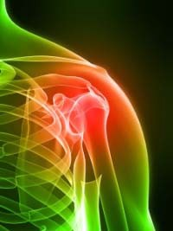

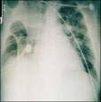

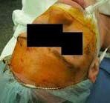



|  |  |  |  |  |
| --- | --- | --- | --- | --- |
| **Resource**  **Name** | **Retail/ Community**  **(n=480)** | **Hospital/**  **Mental Health**  **(n=74)** | **Other (n=50)** | **Total (n=604)** |
| PDA | 82 | 24 | 12 | 118 |
| Use=Yes | 17.1%c | 32.4% | 24.0% | 19.5% |
| PDA | 398 | 50 | 38 | 486 |
| Use=No | 82.9% | 67.6% | 76.0% | 80.5% |
| Data from Schrimsher, Freeman, Kendrach15 | | | | |



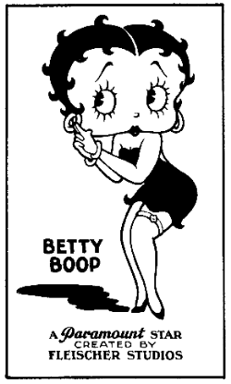



Source: Landman, P.

Body Part, 2009