FIT Travel Scholarship Application - Patch Test Training Workshop
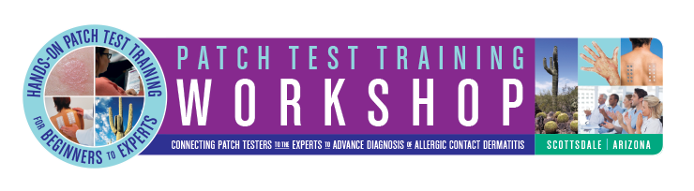

The American College of Allergy, Asthma & Immunology (ACAAI) is excited to present an opportunity for Fellows-in-Training (FITs). The College will be facilitating a limited number of SmartPractice scholarships to the intensive Annual Patch Test Training Workshop in Scottsdale, Arizona on January 11-12, 2019. In support of our commitment to help allergists expand their understanding of this important but underused diagnostic technique, the College will facilitate the process by which eligible FITs will be chosen for this educational grant opportunity. By facilitating this opportunity, the College hopes to promote interest in patch testing and patch test education.

The 2-day workshop provides both didactic and hands-on experience with all aspects of patch testing. Participants have the opportunity to interact with and learn from acknowledged experts in the field. The ultimate goal of the workshop is to arm clinicians with enough clinical and practical information to develop a successful patch test clinic for their institutions or practices.

4 travel grants will be awarded to Allergy Fellows selected by ACAAI. Each grant will consist of complimentary registration to the January 11-12, 2019 Patch Test Training Workshop in Scottsdale, AZ. This grant, valued at $1,400 would include: waived registration fee (valued at $700) and up to $700 to cover travel expenses (flight, hotel, ground transportation, etc).

This is an industry-supported grant by SmartPractice, and as such, the individual travel award amount may be subject to reporting under the Physician Payments Sunshine Act, codified at 42 U.S.C. § 1320a-7h.

Application criteria are as follows:

- Must be an ACAAI member and Allergy/Immunology Fellow-in-Training at the time of the workshop (January 2019)
- Fully completed application, along with current CV
- Letter of Recommendation from the Fellowship Director

Interested individuals must submit the completed application, their CV and the Letter of Recommendation to Mary Campbell at marycampbell@acaai.ororg by September 30, 2018. The selection committee will review and select the final 4 participants by October 10, 2018. Once selected, awardees will be contacted by SmartPractice directly.

Please fill out this application electronically.

First Name |  | Last Name
Address
Email |  | Phone
Fellowship Program |  | Fellowship Year
Why would you like to attend the Annual Patch Test Training Workshop?
Why do you think you should receive the grant to attend?
If you are selected, how do you hope to use the knowledge you will gain in your future practice?
Please email your completed application, your CV and your Letter of Recommendation to Mary Campbell at marycampbell@acaai.org no later than September 30, 2018 to be considered for this grant.
Please email your completed application, CV and Letter of Recommendation to Mary Campbell at marycampbell@acaai.org no later than August 15, 2016 to be considered for the grant.

