FIT OPPORTUNITY: TRAVEL SCHOLARSHIP AWARD HANDS-ON PATCH TEST TRAINING

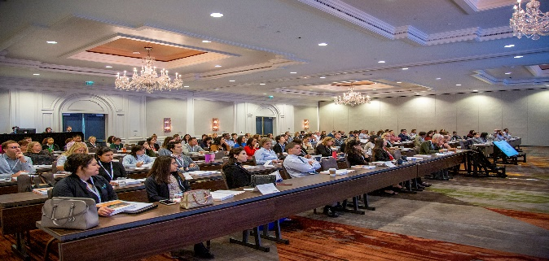

The American College of Allergy, Asthma & Immunology (ACAAI) is excited to announce a special opportunity for Fellows-in-Training (FITs). The College is facilitating five travel grants for the SmartPractice Hands-On Patch Test Training in Phoenix, Arizona on October 15-16, 2021. In support of our commitment to help allergists expand their understanding of this important but underused diagnostic technique, the College will facilitate the process by which eligible FITs will be chosen for this educational grant opportunity. By facilitating this opportunity, the College hopes to promote interest in patch testing and patch test education.

The 2-day workshop provides both didactic and hands-on experience with all aspects of patch testing. Participants will interact with and learn from acknowledged experts in the field. The ultimate goal of the workshop is to arm clinicians with enough clinical and practical information to develop a successful patch test clinic for their institutions or practices.

5 travel grants will be awarded to Allergy Fellows selected by ACAAI. Each grant, valued at $1,900, includes waived registration fee (valued at $900) and up to $1,000 to cover travel expenses (flight, hotel, ground transportation, etc.)

This is an industry-supported grant by SmartPractice, and as such, the individual travel award amount may be subject to reporting under the Physician Payments Sunshine Act, codified at 42 U.S.C. § 1320a-7h.

Application criteria are as follows:
- Must be an ACAAI member and Allergy/Immunology Fellow-in-Training at the time of the workshop (October 2021)
- Fully completed application, along with current CV
- Letter of Recommendation from the Fellowship Director
- Applicants must be U.S.-based fellows in training

Interested individuals must submit the completed application, their CV and the Letter of Recommendation to Mary Campbell at marycampbell@acaai.org by May 31, 2021. The selection committee will review and select the final 5 participants by June 21, 2021. Once selected, awardees will be contacted by SmartPractice directly.

Please fill out this application electronically.

First Name |  | Last Name
Address
Email |  | Phone
Fellowship Program |  | Fellowship Year
Why would you like to attend the Annual Patch Test Training Workshop?
Why do you think you should receive the grant to attend?
If you are selected, how do you hope to use the knowledge you will gain in your future practice?
Please email your completed application, your CV and your Letter of Recommendation to Mary Campbell at marycampbell@acaai.org no later than May 31, 2021 to be considered for this grant.

